

**DataLens: Interactive**

**Government Data Visualization**

# PROBLEM STATEMENT

India’s government datasets across sectors like agriculture, education, and finance offer valuable insights for decision-making. However,

the raw data is often complex and difficult to interpret. Without effective data visualization, it becomes challenging to transform this data

into clear, actionable insights, hindering informed decision-making and impactful solutions.

# PROJECT OVERVIEW

Our project aims to bridge this gap by:

* Transforming raw government data into interactive visualizations.
* Developing a user-friendly dashboard with changeable parameters.
* Enhancing data accessibility for policymakers, researchers, and the public.
* Utilizing various graph types(bar charts, pie charts, heatmaps, etc.) to improve data driven insights.

# SOLUTION OFFERED

Our project provides an interactive dashboard that allows users to explore government datasets efficiently. The dashboard integrates various data visualization techniques to simplify complex datasets and present them in an easily understandable format. By leveraging dynamic filters and multiple graphical representations, users can derive meaningful insights and make informed decisions.

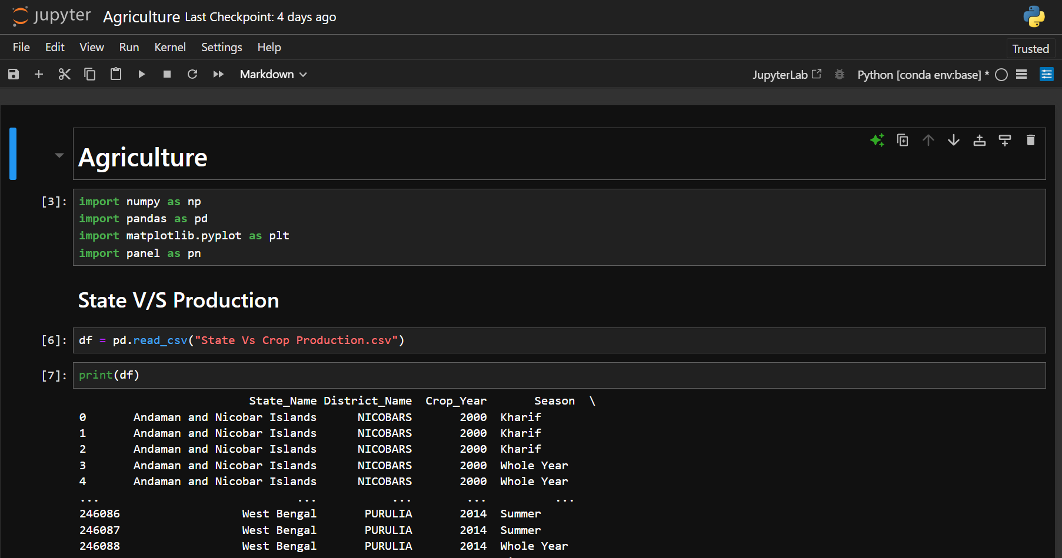

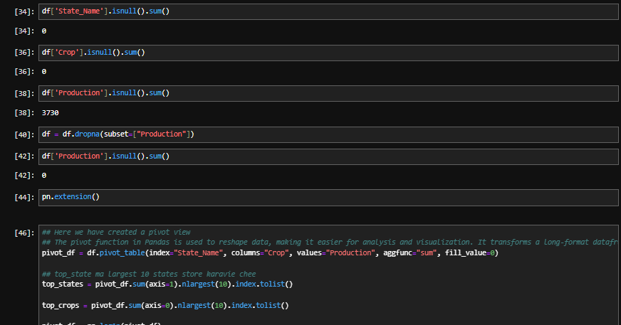

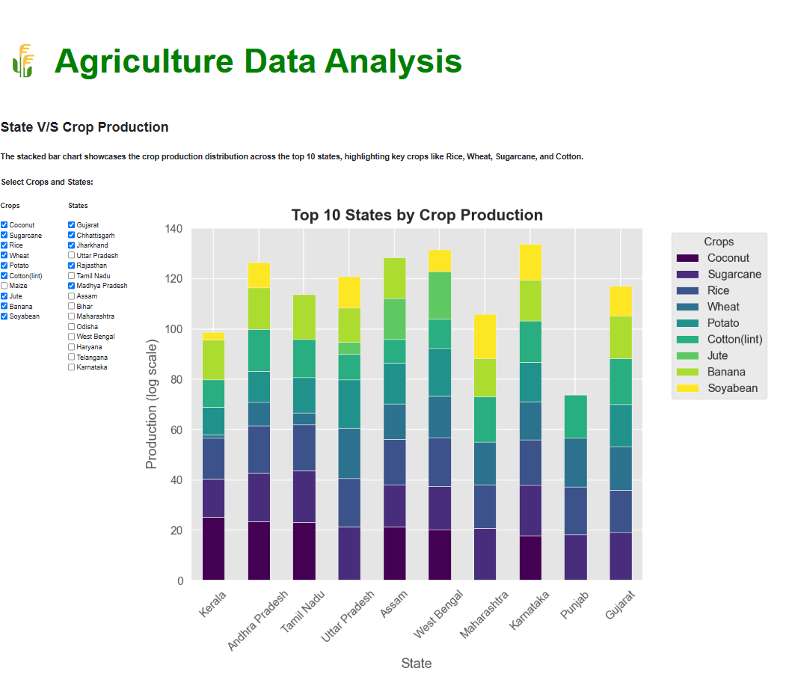

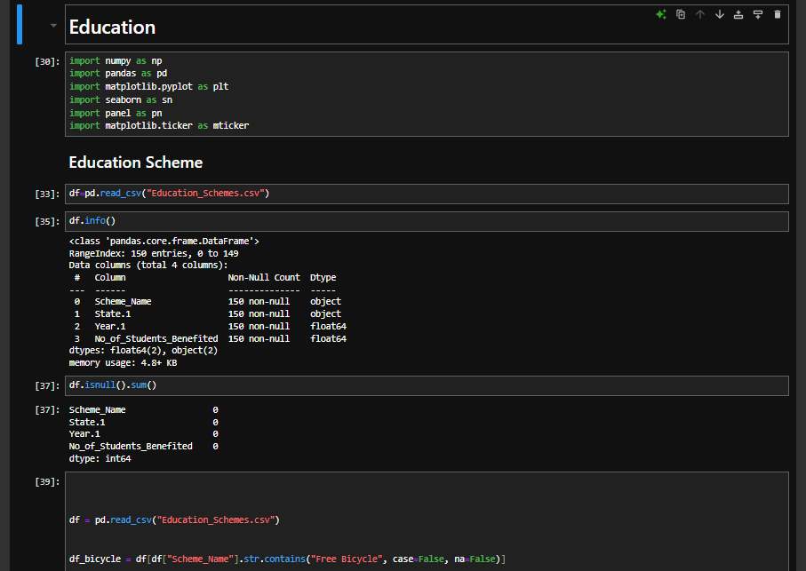

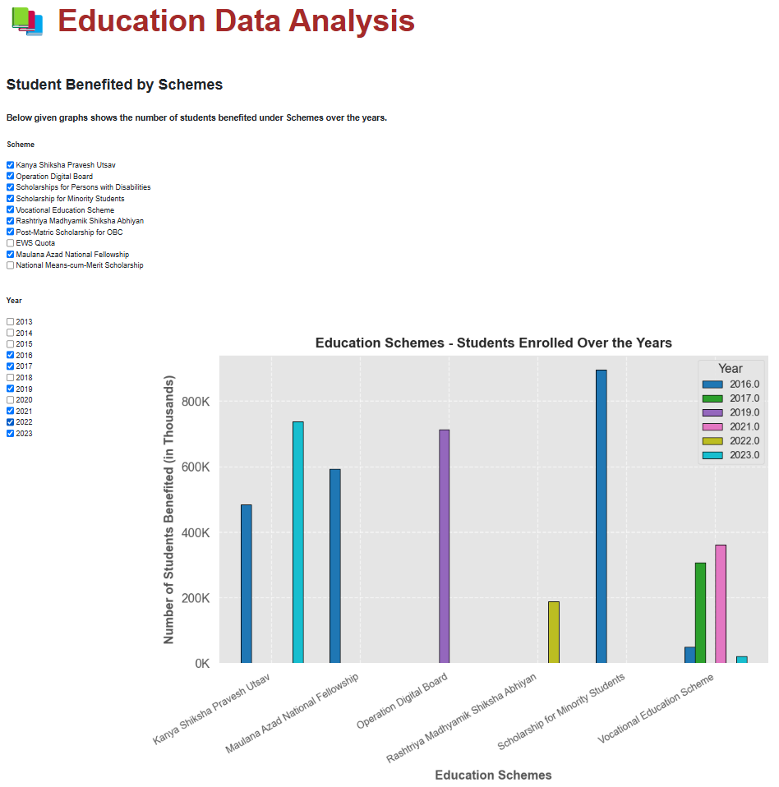

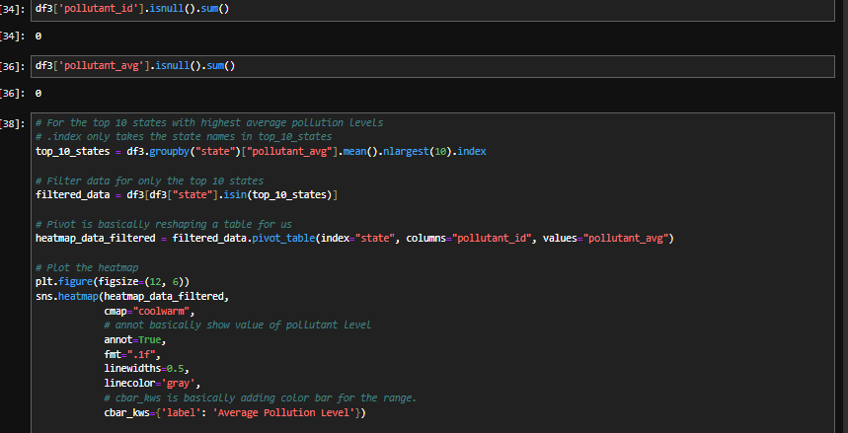

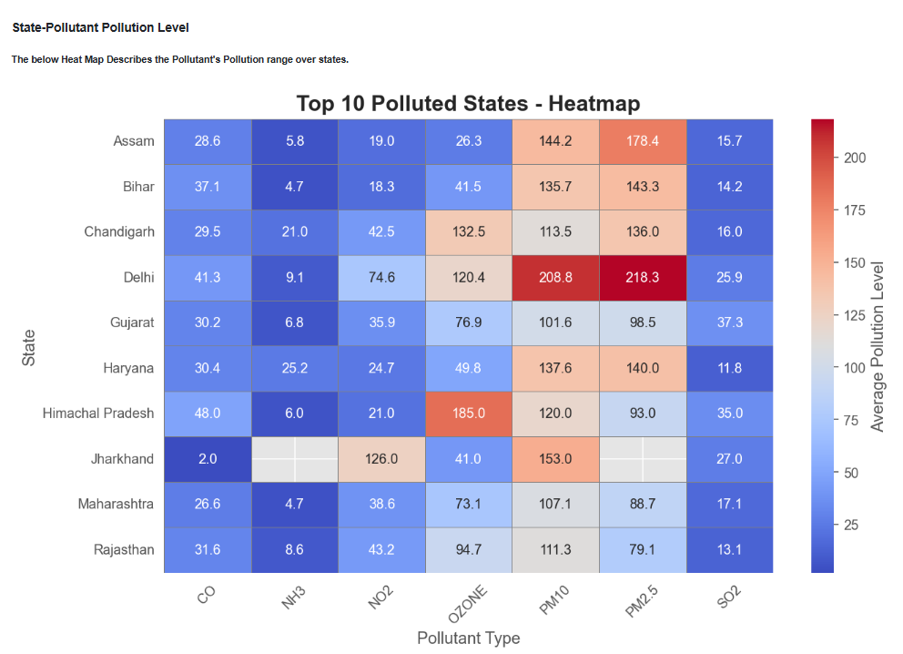

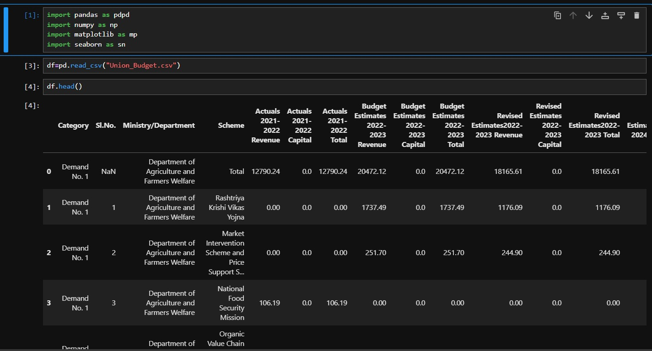

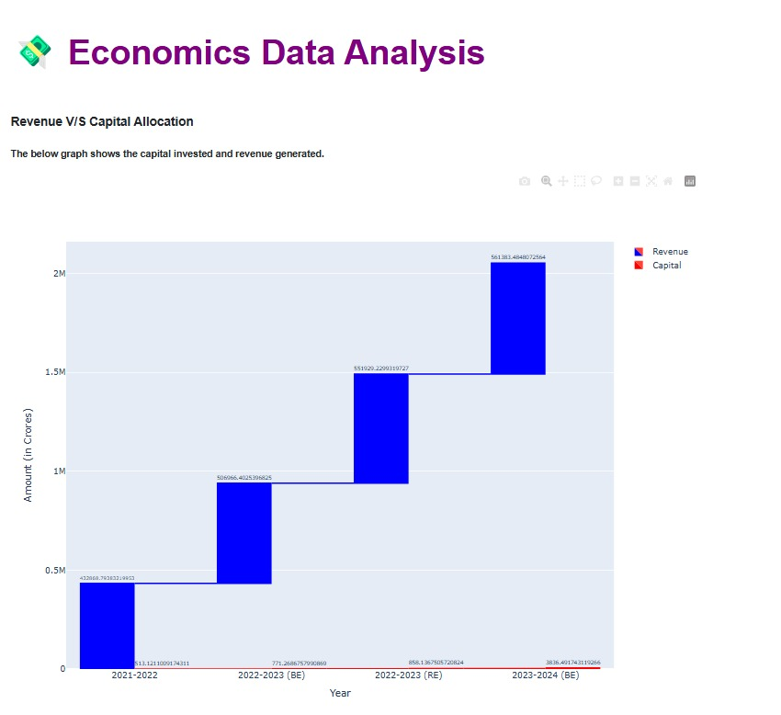

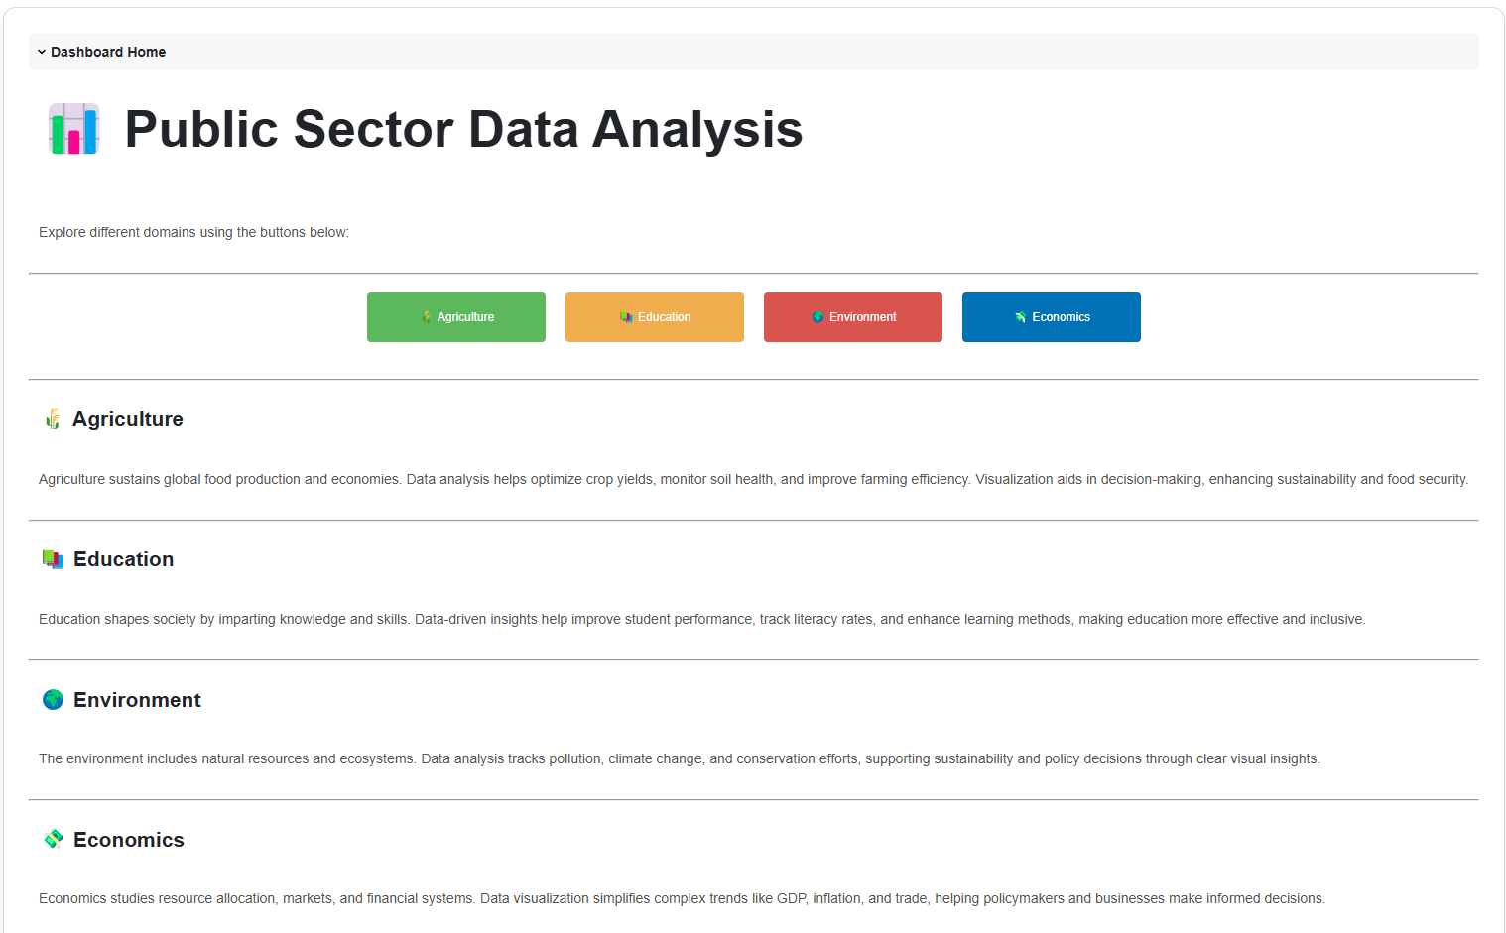

Further Details are Connected in the Repository.

Repo,

<https://github.com/ashutosh-bhagat/DataLens--Govt.-Data-Visualization>

# WHO ARE THE END USERS?

* **Government Agencies – For policy formulation and impact assessment.**
* **Researchers & Data Analysts – For conducting data-driven studies.**
* **Public & Media – For understanding trends and government initiatives.**
* **Startups & Businesses – To identify market trends, government incentives, and investment opportunities.**

# TECHNOLOGY USED TO SOLVE THE PROBLEM

* **Data Processing & Analysis:** Python (Pandas, NumPy, Matplotlib, Seaborn)
* **Dashboard Development:** Panel (for interactive visualization)